**Week 1 portfolio**

**Reflections.**

During week 1 I was able to learn the basics of Web App Design and development. I was introduced to the basics of computer networks and key points. Some of the things I learned are

* Client - Server networks : Describes the computers that receive services and computers that provide services respectively.
* internet and Internet : The internet with simple “i” refers to a group of computers that are connected together forming a computer network. Where as the Internet with capital “I” is the entire collection of networks on the planet, which is the biggest network of computing systems and computer networks.
* WWW : WWW or the World Wide Web is a collection of electronic documents that are linked together.
* Hypertext Document : A document which contains the links to other documents,and are highlighted words in text or graphics.
* URL (Uniform Resource Locator) : The unique address of each page. It acts as the identifier of the pages location on the server.
* HTTP (Hyper Text Transfer Protocol) : Describes the way hypertext Documents are fetched over the internet.

I also learned about web servers, web applications and HTML including HTML versions. I also learned basic HTML tags on the first week. Some are

* Header tags.
* Text adjusting tags.
* Nested tags etc. And we were asked to do a research on tags.

**Tasks.**

**Resume.**

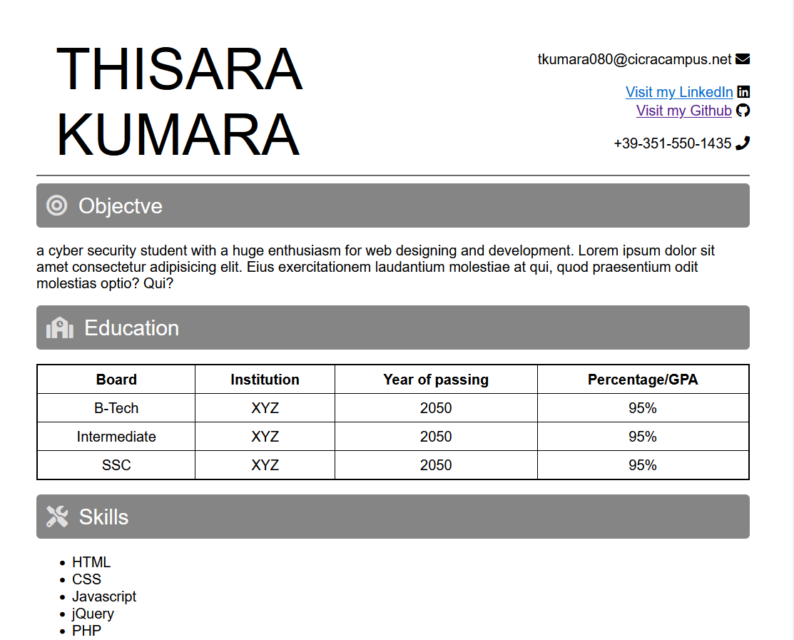

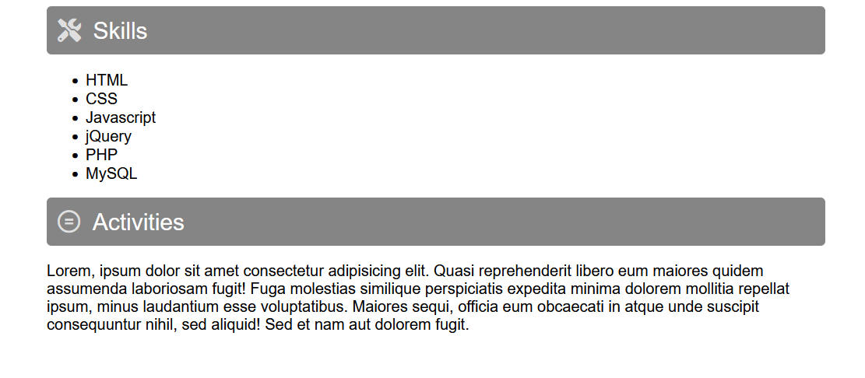

Git hub link : https://github.com/river080/SIT120-RWA-assignments/tree/main/week1